Boletim de Indicadores APS

CS COSTEIRA DO PIRAJUBAE - Equipe 300

2023-08-17

## Indicador 1 - Cobertura de consultas de pré-natal

| Mes | Equipe | Unidade | Municipio |
| --- | --- | --- | --- |
| 2022-08-01 | 50 | 80.00 | 64.08 |
| 2022-09-01 | 0 | 50.00 | 62.54 |
| 2022-10-01 | - | 50.00 | 65.54 |
| 2022-11-01 | 25 | 50.00 | 65.86 |
| 2022-12-01 | 75 | 76.92 | 65.45 |
| 2023-01-01 | 100 | 100.00 | 62.85 |
| 2023-02-01 | 50 | 66.67 | 66.67 |
| 2023-03-01 | 0 | 63.64 | 65.96 |
| 2023-04-01 | 100 | 100.00 | 67.16 |
| 2023-05-01 | 100 | 72.73 | 65.59 |
| 2023-06-01 | 75 | 83.33 | 61.42 |
| 2023-07-01 | 100 | 90.00 | 62.47 |

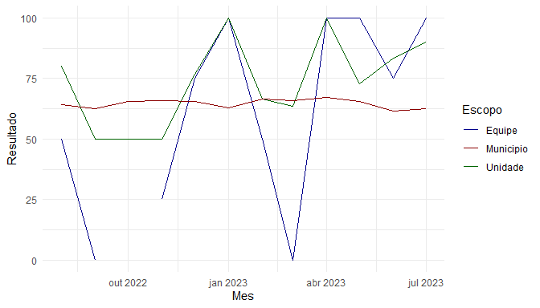

## Indicador 2 - Proporção de gestantes com exame de HIV e Sífilis

| Mes | Equipe | Unidade | Municipio |
| --- | --- | --- | --- |
| 2022-08-01 | 50.00 | 93.33 | 86.05 |
| 2022-09-01 | 100.00 | 83.33 | 89.91 |
| 2022-10-01 | - | 90.00 | 90.77 |
| 2022-11-01 | 75.00 | 87.50 | 88.82 |
| 2022-12-01 | 75.00 | 92.31 | 90.65 |
| 2023-01-01 | 100.00 | 100.00 | 87.53 |
| 2023-02-01 | 75.00 | 88.89 | 89.72 |
| 2023-03-01 | 66.67 | 90.91 | 89.91 |
| 2023-04-01 | 100.00 | 100.00 | 89.55 |
| 2023-05-01 | 100.00 | 100.00 | 87.53 |
| 2023-06-01 | 100.00 | 100.00 | 89.95 |
| 2023-07-01 | 100.00 | 100.00 | 86.86 |

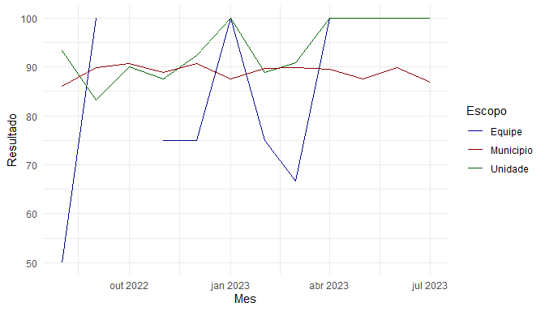

## Indicador 3 - Proporção de gestantes com atendimento odontológico

| Mes | Equipe | Unidade | Municipio |
| --- | --- | --- | --- |
| 2022-08-01 | 50.00 | 86.67 | 72.09 |
| 2022-09-01 | 100.00 | 66.67 | 71.18 |
| 2022-10-01 | - | 90.00 | 77.23 |
| 2022-11-01 | 75.00 | 87.50 | 74.02 |
| 2022-12-01 | 50.00 | 69.23 | 77.66 |
| 2023-01-01 | 100.00 | 100.00 | 69.21 |
| 2023-02-01 | 50.00 | 77.78 | 68.89 |
| 2023-03-01 | 66.67 | 81.82 | 69.72 |
| 2023-04-01 | 100.00 | 100.00 | 67.41 |
| 2023-05-01 | 100.00 | 100.00 | 66.83 |
| 2023-06-01 | 100.00 | 100.00 | 75.11 |
| 2023-07-01 | 100.00 | 90.00 | 78.28 |

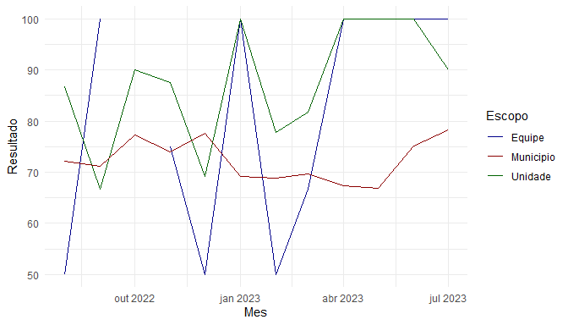

## Indicador 4 - Proporção de mulheres com citopatológico nos últimos 3 anos

| Mes | Equipe | Unidade | Municipio |
| --- | --- | --- | --- |
| 2022-08-01 | 18.90 | 23.27 | 9.76 |
| 2022-09-01 | 20.23 | 25.27 | 10.28 |
| 2022-10-01 | 20.21 | 25.86 | 10.66 |
| 2022-11-01 | 21.58 | 27.24 | 11.26 |
| 2022-12-01 | 22.69 | 28.12 | 11.54 |
| 2023-01-01 | 23.31 | 28.74 | 11.71 |
| 2023-02-01 | 24.00 | 29.74 | 11.98 |
| 2023-03-01 | 24.08 | 30.18 | 12.21 |
| 2023-04-01 | 24.62 | 31.02 | 12.51 |
| 2023-05-01 | 25.28 | 31.47 | 12.71 |
| 2023-06-01 | 25.84 | 32.04 | 13.01 |
| 2023-07-01 | 26.09 | 32.35 | 13.19 |

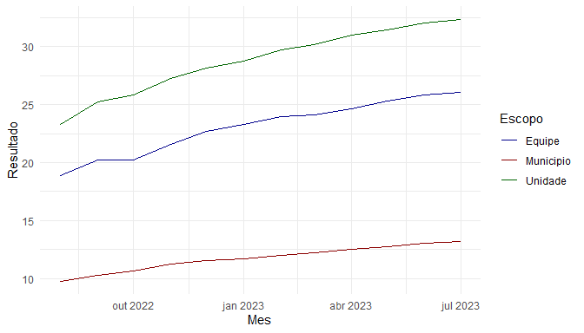

## Indicador 5 - Proporção de crianças com a terceira dose das vacinas Penta e VIP

| Mes | Equipe | Unidade | Municipio |
| --- | --- | --- | --- |
| 2022-08-01 | 75.00 | 87.50 | 60.21 |
| 2022-09-01 | 100.00 | 75.00 | 61.04 |
| 2022-10-01 | 60.00 | 78.57 | 58.41 |
| 2022-11-01 | 100.00 | 100.00 | 60.55 |
| 2022-12-01 | 66.67 | 92.86 | 61.48 |
| 2023-01-01 | 85.71 | 82.35 | 55.49 |
| 2023-02-01 | 100.00 | 100.00 | 56.65 |
| 2023-03-01 | 100.00 | 83.33 | 60.33 |
| 2023-04-01 | 100.00 | 91.67 | 57.56 |
| 2023-05-01 | 100.00 | 100.00 | 60.14 |
| 2023-06-01 | 0.00 | 70.00 | 66.27 |
| 2023-07-01 | 100.00 | 100.00 | 63.30 |

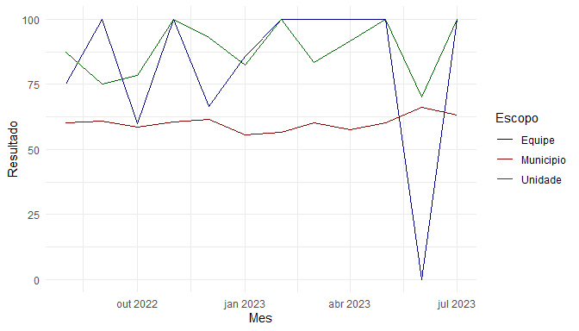

## Indicador 6 - Proporção de hipertensos com consulta e aferição de PA no semestre

| Mes | Equipe | Unidade | Municipio |
| --- | --- | --- | --- |
| 2022-08-01 | 14.77 | 28.72 | 29.19 |
| 2022-09-01 | 15.08 | 32.62 | 33.71 |
| 2022-10-01 | 15.90 | 32.59 | 35.19 |
| 2022-11-01 | 15.55 | 33.89 | 36.97 |
| 2022-12-01 | 16.16 | 33.23 | 37.34 |
| 2023-01-01 | 17.07 | 34.27 | 39.23 |
| 2023-02-01 | 28.35 | 36.21 | 38.96 |
| 2023-03-01 | 30.00 | 33.76 | 37.07 |
| 2023-04-01 | 29.61 | 34.07 | 37.08 |
| 2023-05-01 | 32.33 | 33.11 | 37.67 |
| 2023-06-01 | 34.43 | 33.85 | 38.24 |
| 2023-07-01 | 40.60 | 35.42 | 37.55 |

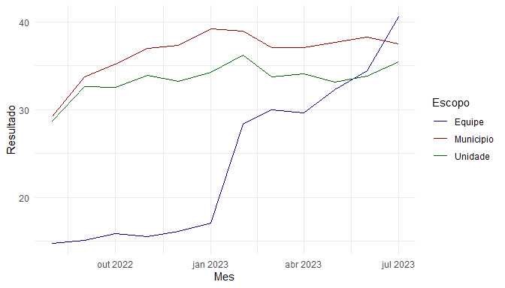

## Indicador 7 - Proporção de diabéticos com consulta e exame de HbA1c no semestre

| Mes | Equipe | Unidade | Municipio |
| --- | --- | --- | --- |
| 2022-08-01 | 16.44 | 33.28 | 31.33 |
| 2022-09-01 | 19.86 | 36.11 | 35.97 |
| 2022-10-01 | 17.12 | 36.44 | 36.36 |
| 2022-11-01 | 19.18 | 39.71 | 37.97 |
| 2022-12-01 | 19.73 | 40.63 | 38.77 |
| 2023-01-01 | 23.81 | 48.35 | 42.50 |
| 2023-02-01 | 60.54 | 52.20 | 41.85 |
| 2023-03-01 | 61.90 | 51.06 | 39.97 |
| 2023-04-01 | 63.95 | 51.76 | 40.84 |
| 2023-05-01 | 65.31 | 54.62 | 41.94 |
| 2023-06-01 | 65.31 | 53.92 | 42.02 |
| 2023-07-01 | 72.11 | 61.76 | 41.06 |

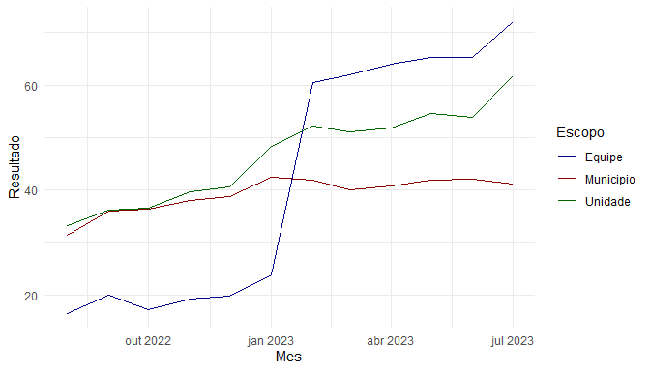

## Indicador 8 - Proporção de pessoas com consulta Med/Enf/Odo no último ano com CPF registrado

| Equipe | Unidade | Municipio |
| --- | --- | --- |
| 96.35 | 97.47 | 98.36 |

## Indicador 9.1 - Percentual da população ativa com 1 consulta odontológica no ano

| Equipe | Unidade | Municipio |
| --- | --- | --- |
| 18.15 | 18.12 | 14.68 |

## Indicador 9.2 - Percentual da população ativa com 1 consulta médica no ano

| Equipe | Unidade | Municipio |
| --- | --- | --- |
| 55.38 | 61.32 | 58.69 |

## Indicador 9.3 - Percentual da população ativa com 1 consulta de enfermagem no ano

| Equipe | Unidade | Municipio |
| --- | --- | --- |
| 47.7 | 45.66 | 44.53 |

## Indicador 10 - PVHA com ao menos uma consulta médica em APS no semestre

| Mes | Equipe | Unidade | Municipio |
| --- | --- | --- | --- |
| 2022-08-01 | 68.29 | 63.91 | 58.31 |
| 2022-09-01 | 63.41 | 65.29 | 58.46 |
| 2022-10-01 | 58.54 | 66.08 | 57.92 |
| 2022-11-01 | 65.85 | 68.79 | 57.46 |
| 2022-12-01 | 53.66 | 66.09 | 56.76 |
| 2023-01-01 | 58.54 | 69.54 | 57.22 |
| 2023-02-01 | 60.98 | 71.59 | 57.62 |
| 2023-03-01 | 59.52 | 71.51 | 57.17 |
| 2023-04-01 | 55.81 | 68.33 | 57.50 |
| 2023-05-01 | 58.14 | 67.03 | 57.59 |
| 2023-06-01 | 58.14 | 65.57 | 57.92 |
| 2023-07-01 | 60.47 | 65.95 | 58.33 |

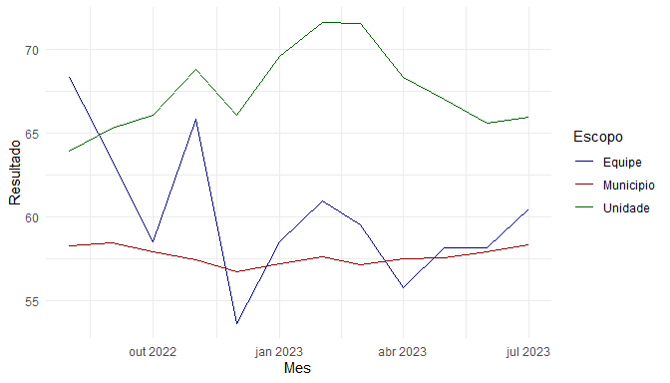

## Indicador 12 - Taxa de resolutividade

| Mes | Equipe | Unidade | Municipio |
| --- | --- | --- | --- |
| 2022-08-01 | 93.54 | 90.56 | 87.98 |
| 2022-09-01 | 89.86 | 89.55 | 88.00 |
| 2022-10-01 | 92.45 | 91.63 | 88.36 |
| 2022-11-01 | 92.35 | 91.19 | 89.38 |
| 2022-12-01 | 92.77 | 92.64 | 89.86 |
| 2023-01-01 | 90.08 | 90.78 | 88.87 |
| 2023-02-01 | 80.56 | 90.75 | 87.96 |
| 2023-03-01 | 91.67 | 90.99 | 88.50 |
| 2023-04-01 | 90.46 | 90.42 | 90.02 |
| 2023-05-01 | 89.74 | 89.63 | 89.18 |
| 2023-06-01 | 93.61 | 92.06 | 88.62 |
| 2023-07-01 | 89.46 | 89.89 | 87.55 |

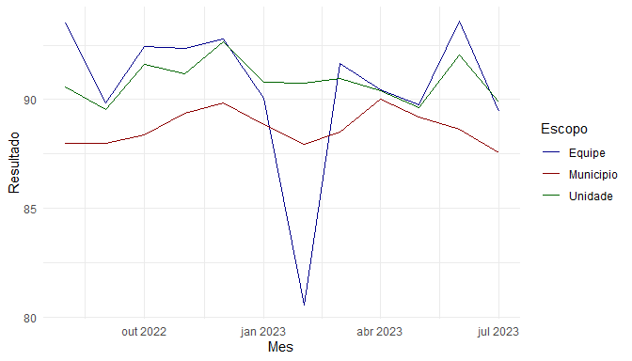

## Indicador 13 - Proporção de pessoas vinculadas exclusivamente à UPA para consultas médicas

| Equipe | Unidade | Municipio |
| --- | --- | --- |
| 27.84 | 27 | 26.85 |

## Indicador 14 - Percentual de devolvidos respondidos em até 7 dias

| Mes | Equipe | Unidade | Municipio |
| --- | --- | --- | --- |
| 2022-08-01 | 4.90 | 5.77 | 5.96 |
| 2022-09-01 | 6.06 | 6.73 | 5.17 |
| 2022-10-01 | 4.76 | 4.82 | 4.32 |
| 2022-11-01 | 6.74 | 6.82 | 5.19 |
| 2022-12-01 | 5.43 | 6.06 | 5.15 |
| 2023-01-01 | 5.54 | 5.57 | 5.24 |
| 2023-02-01 | 11.27 | 6.02 | 4.63 |
| 2023-03-01 | 5.04 | 5.36 | 4.28 |
| 2023-04-01 | 3.59 | 3.65 | 3.51 |
| 2023-05-01 | 5.26 | 4.45 | 3.83 |
| 2023-06-01 | 2.36 | 4.00 | 3.78 |
| 2023-07-01 | 7.48 | 4.84 | 3.87 |

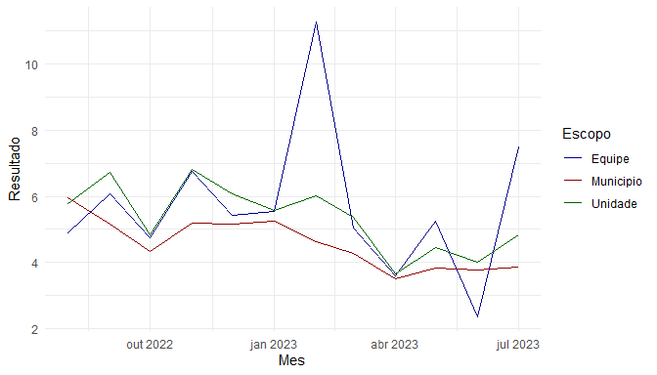

## Indicador 15 - Percentual de inserções devolvidas pela regulação

| Mes | Equipe | Unidade | Municipio |
| --- | --- | --- | --- |
| 2022-08-01 | 42.86 | 35.42 | 48.18 |
| 2022-09-01 | 12.50 | 44.64 | 43.75 |
| 2022-10-01 | 22.22 | 45.83 | 45.67 |
| 2022-11-01 | 38.46 | 46.15 | 45.95 |
| 2022-12-01 | 28.57 | 36.17 | 43.35 |
| 2023-01-01 | 56.25 | 50.85 | 42.64 |
| 2023-02-01 | 50.00 | 39.47 | 43.96 |
| 2023-03-01 | 50.00 | 43.14 | 42.12 |
| 2023-04-01 | 14.29 | 53.33 | 43.27 |
| 2023-05-01 | 41.67 | 41.30 | 39.32 |
| 2023-06-01 | 33.33 | 50.00 | 45.22 |
| 2023-07-01 | 37.50 | 40.38 | 49.11 |

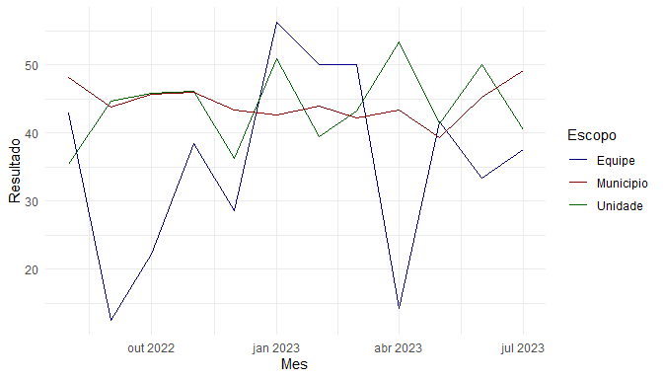

## Indicador 16 - Proporção de pacientes com CID F32 (episódio depressivo) em acompanhamento exclusivo na APS

| Equipe | Unidade | Municipio |
| --- | --- | --- |
| 21.15 | 20 | 21.79 |